MACH4METAL

metalworking machinery
Transito 21, 6909 DA Babberich, Netherlands
Tel. + 31 (0)316 – 247123
Fax. + 31 (0)316 - 247956
info@mach4metal.com
www.mach4metal.com
Bank No : 66.52.13.883
IBAN : NL33 INGB 0665 2138 83
BIC : INGBNL2A
VAT : NL 815393635B01

HOESCH railway - wheel set pres

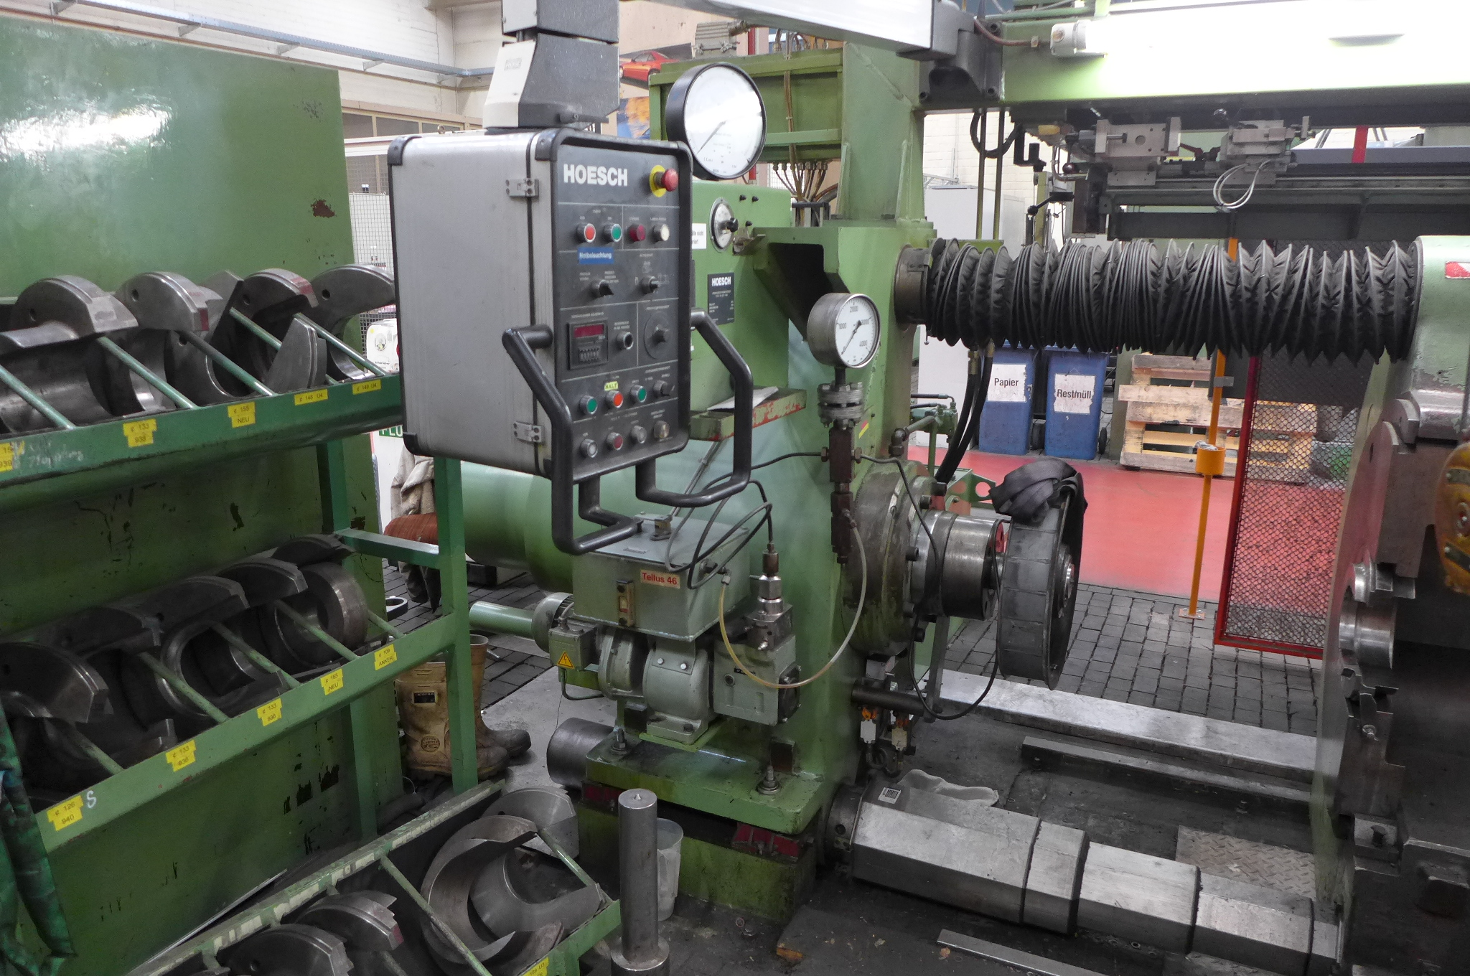
- Make : MFD HOESCH - Germany
- Typ : PR 250 / 1000
- Age : 1992

- Height of centre : 500
- Max. wheel Ø : 1.000 mm
- Max. pressing force : 250 ton

- Max. cylinder stroke : 500 mm
- Cylinder Ø : 300 mm
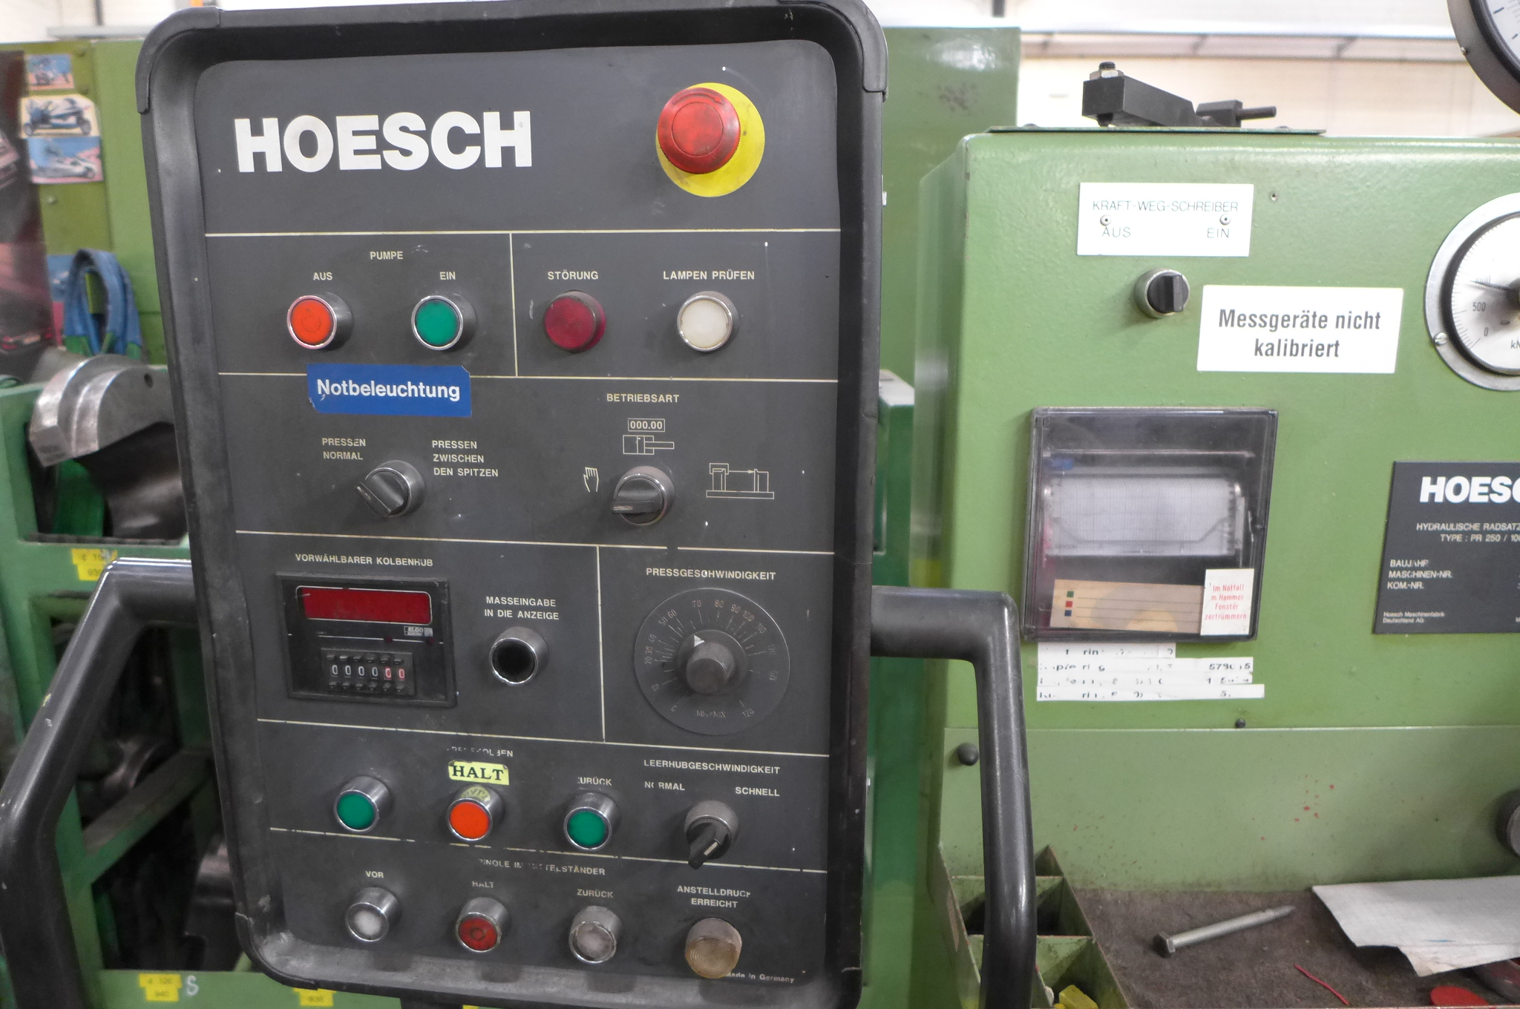
- Cylinder piston Ø : 270 mm

- Max. working force: 360 bar
- Pressing speed : 0 - 80 mm/min
- Pinole feed : 0 – 1300 mm/min
- Return speed : 0 – 1300 mm/min

- Centring device
- Centre angle : 90°
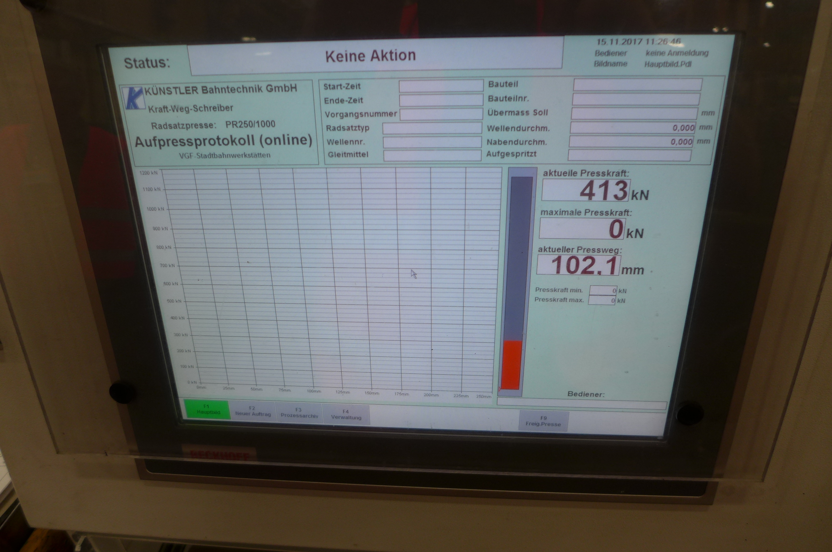
- Pinole diam. Ø : 100 mm
- Cylinder diam. Ø : 110 mm
- Pinole stroke : 500 mm

- Recently retrofitted Kuenstler Bahntechnik
- New PC for making marking & measuring protocol
- Incl. calibration system

- Big package with different flanches ring for Ø
- Ex. German service company for railway systems
- Machine can service wheel sets general use

Please Note: The above information has been obtained to the best of our ability and belief from, and from the manufacturers where possible. It is given in good faith, but its accuracy can not be guaranteed. Accordingly, it will not form a representation or constitute contractual terms. We advise you to check any vital details!

